PATH Intl. Demo Only Driving Workshop

Registration Deadline: March 15th

Friday April 12th - Saturday April 13th
(8 am-6 pm) (8am-3pm)

Location: Intermountain Equestrian Center

7256 US Highway 3 Billings, MT 59106

Cost: $150
Cost (RMC Students/Montana Residents): $60
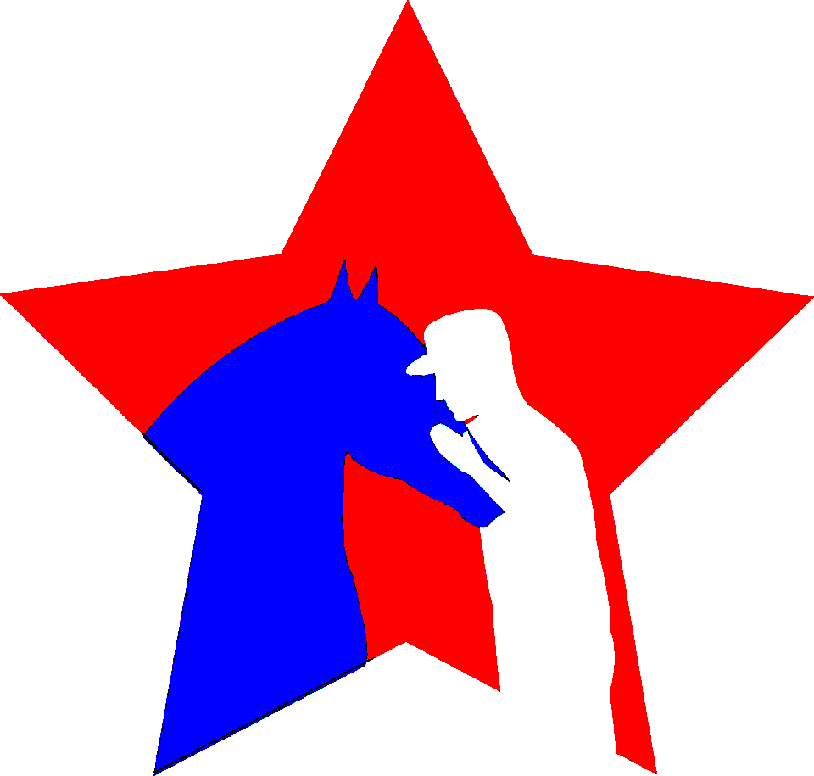

RSVP to Program Director, Amanda Ott to Reserve a Spot
(406) 208-9774
aott@horsesspiritshealing.org

